PARADISE HOTEL BUSAN  RESERVATION REQUEST | SQM-2022  (2021.06.13~06.18)
*Check In Date: |  | *Check Out Date: | 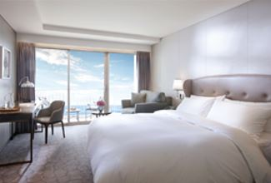  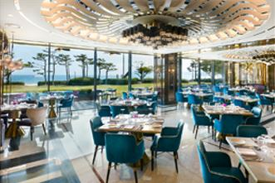  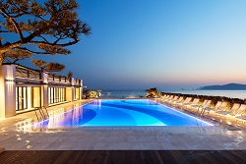
*No. of Persons:
*Name:
*Telephone: |  | *E-mail:
*PAYMENT (For Guarantee)
Credit Card Type: ☐Etc. ☐Visa ☐Masters ☐Amex(4Digit-number : )
Expiry Date:
Credit Card Number:
Card Holder’s Name:
ROOM TYPE |  | *SPECIAL ROOM RATE | OTHERS RATE
DELUXE CITY VIEW |  | ☐ KRW 217,800 (King)  ☐ KRW 217,800 (Twin) | ☐Breakfast Buffet  (Guarantee Discount)  KRW 30,250/ Person  (사전예약할인,변경불가)  ☐Breakfast Buffet  KRW 42,000/ Person  (현장예약요금)  ☐Extra Bed: KRW72,600/Day
DELUXE OCEAN VIEW |  | ☐ KRW 242,000 (King)
DELUXE OCEAN TERRACE VIEW |  | ☐ KRW 290,400 (King)  ☐ KRW 290,400 (Twin)
※ Saturday Surcharge(토요일 추가요금) : KRW 84,700
* The rates above are non-commissionable, and they are Inclusive of 10% Service Charge and 10% Government Tax.
* The rates above are Not Included breakfast.
* Check-in time is 3p.m. Check out time is 11:30 a.m. (If you pass the check-out time, the following rates will apply)
Until 3pm: 50% of the room rate, After 3pm: 100% of the room rate
* FREE ACCESS : Swimming pool, Fitness center, Play station zone, Kids zone
* 50% Special Discount on admission to Sauna and Outdoor hot spring ‘Cimer’
* CANCELLATION POLICY (Policies: Cancellation or No-Show after the room reservation is being charged as below:
From 7days to 4days prior to Arrival date : 30% of the Room charge/ From 3days to 2days prior to Arrival date : 50% of the Room charge/ From 1days or less prior to Arrival date : no refund)
If you cancel or no-show, Cancellation fee will be charged automatically with the above credit card without further notice.
*signature(서명): .
Please send reservation to: res@paradisehotel.co.kr or call Tel no. +82.51.749.2111-3

